INTERNATIONAL ORGANISATION FOR STANDARDISATION
ORGANISATION INTERNATIONALE DE NORMALISATION
ISO/IEC JTC 1/SC 29/WG 11
CODING OF MOVING PICTURES AND AUDIO

ISO/IEC JTC 1/SC 29/WG 11 N11230
Kyoto, Japan – January 2010

Source: | Requirements
Title: | Context and Objectives for Advanced IPTV Terminal (AIT)
Purpose | Output

Context and Objectives for Advanced IPTV Terminal (AIT)

Introduction
This document highlights the context and objectives of a standardisation project called Advanced IPTV Terminal (AIT). The purpose of AIT standard is the standardisation of a flexible set of protocols and interfaces that will enable new forms of digital media services that will innovate the current landscape of digital media services in a variety of environments such as broadcast, managed and unmanaged networks, hybrid delivery systems etc.

The AIT standard will be produced as a collaborative project of MPEG and ITU-T Q.13 of SG 16 (Q.13/16). However, it is expected that the AIT standard will stand out from other ITU-T recommendations under development such as the basic IPTV terminals [1] and the full fledged [2] and mobile IPTV terminals [3], but also from other IPTV-related standardisation initiatives.

Implementation of the AIT standard can benefit from the existing MPEG Multimedia Middleware (ISO/IEC 23004) [4] and MPEG eXtensible Middleware (MXM) (ISO/IEC 23006) [5] standards.

Context
A number of technology and business developments such as the deployment of broadband networks enabling new ways to deliver and exchange multimedia services and the improvement of hardware performance allowing many service aspects to be implemented as software are having substantial impacts on media services-related businesses. These are opening new business opportunities for multimedia services, such as IPTV services.

The purpose of the AIT standard is to leverage on advanced technologies to bring into IPTV services the buoyancy of new exciting initiatives – sometimes assembling millions of users in a fortnight – that pop up almost every day with new features such as open APIs and the possibility for third parties to provide applications to those APIs.

Over the years MPEG and ITU-T have been the providers of some critical enabling technologies and have developed a huge portfolio of standards and recommendations that can be assembled to provide multimedia services. Continuing their approach of providing standards and recommendations for the next generation of products, services and applications, MPEG and ITU-T Q.13/16 are developing AIT, a standard for “advanced” IPTV services. AIT will be based on a flexible service framework capable of accommodating and extending in an interoperable fashion many of the features that are currently found in new environments.

Objectives
The AIT standard will support the service providers’ drive to deploy innovative multimedia services such as those described in [6] identifying a set of “Elementary Services” and defining the corresponding set of protocols and APIs to enable any user in an AIT value chain to access those services in an interoperable fashion. Note that an AIT value chain is a collection of Users, including Creators, End Users and Service Providers, that conforms to the AIT standard.

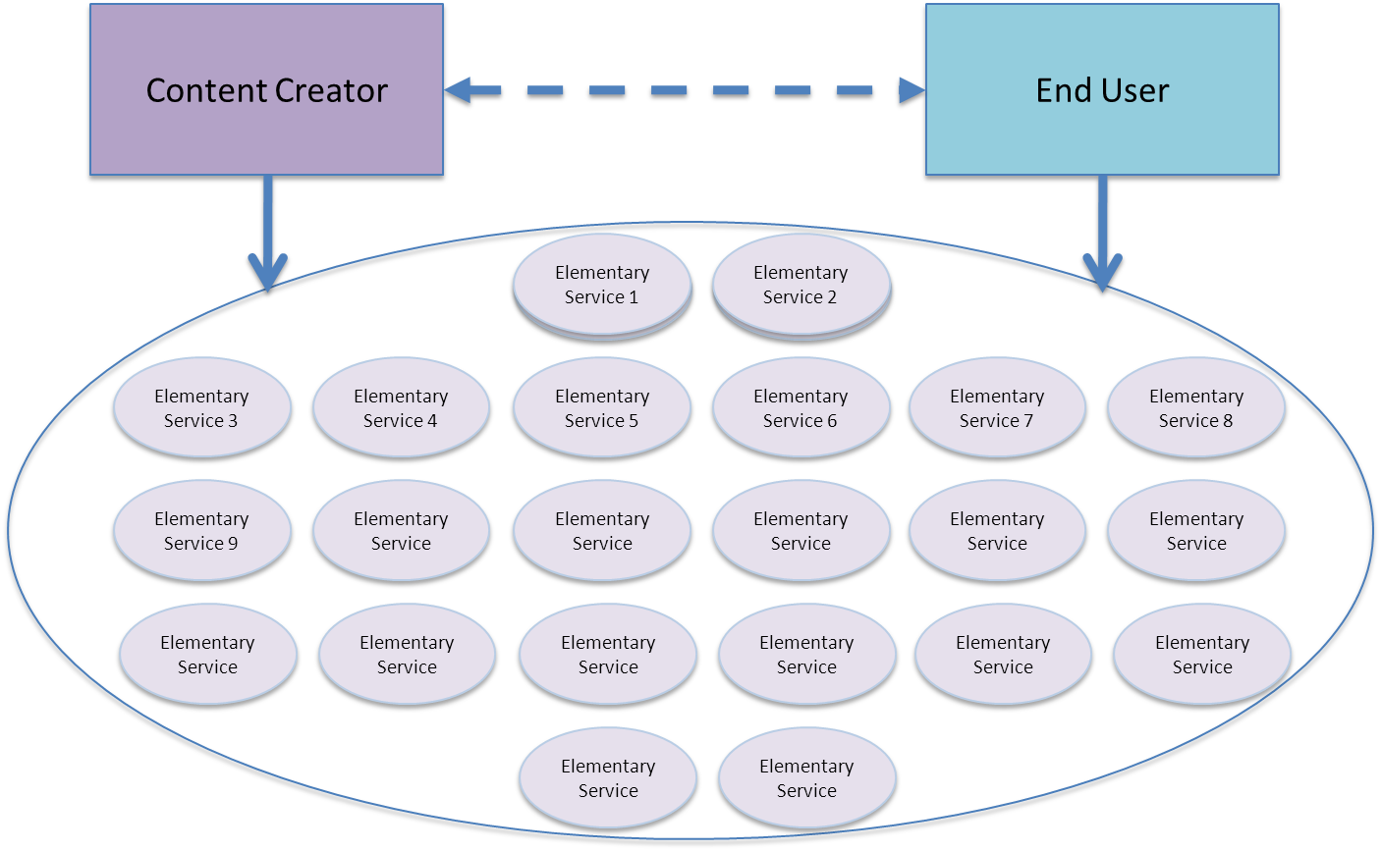

Figure 1 – The AIT Ecosystem

Figure 1 depicts the AIT standard-enabled digital media service eco-system underpinning and supporting the activities of content creators and consumers.

provides an initial list of Elementary Services identified so far with a short description for each.

Elementary Service | Description
Authenticate  Content | Allowing Users to confirm the identity of a Content item in an AIT value chain
Deliver Content | Allowing Users to transfer Content between Users of an AIT value chain
Describe Content | Allowing Users to associate metadata to Content in an AIT value chain
Identify Content | Allowing Users to assign Identifiers to Content in an AIT value chain
Interact with Content | Allowing Users to trigger an action within an AIT value chain through Content presented
Package Content | Allowing Users to make Content ready for delivery
Post Content | Allowing Users to let other Users access their Content
Present Content | Allowing Users to experience Content
Process Content | Allowing Users in an AIT value chain to perform operations on Content
Store Content | Allowing Users to save Content for later use
Verify Content | Allowing Users to check the integrity of Content
Authenticate Contract | Allowing Users to confirm the identity and signers of a Contract in an AIT value chain
Check With Contract | Allowing Users to verify if a usage request matches with the content (e.g., obligations, prohibitions) expressed in a Contract
Create Contract | Allowing Users to generate a Contract in an AIT value chain
Deliver Contract | Allowing Users to transfer Contract between Users of an AIT value chain
Identify Contract | Allowing Users to assign Identifiers to Contract in an AIT value chain
Negotiate Contract | Allowing Users of an AIT value chain to achieve an agreement on the terms and conditions of use e.g., obligations and prohibitions, with respect to a Content item, a Device or a Service
Post Contract | Allowing Users to let other Users access their Contract
Present Contract | Allowing Users to understand Contract
Process Contract | Allowing Users to change the content of a Contract
Request | Allowing Users to request for a Contract in an AIT value chain
Revoke Contract | Allowing Users to discontinue the validity of a Contract
Store Contract | Allowing Users to save Contract for later use
Verify Contract | Allowing Users to check the integrity of a Contract in an AIT value chain
Authenticate Device | Allowing Users to confirm the identity of a Device
Authorise Device | Allowing Users to obtain authorization of some usage(s) by a Device
Deliver Device | Allowing Users to transfer a Device between Users of an AIT value chain
Describe Device | Allowing Users to associate metadata to Devices of an AIT value chain
Identify Device | Allowing Users to assign a unique Identifier to Devices of an AIT value chain
Install Device | Allowing Users to install a Device
Interact With Device | Allowing Users to trigger an action within an AIT value chain through Device presented
Process Device | Allowing Users in an AIT value chain to perform operations on Device
Request Device | Allowing Users to request for a Device in an AIT value chai
Revoke Device | Allowing Users to discontinue the validity of a Device
Uninstall Device | Allowing Users to unstall a Device
Verify Device | Allowing Users to check the integrity of a Device
Report Event | Allowing Users to report an Event that has occurred in an AIT value chain
Request Event | Allowing Users to request the creation of an Event Report for one or more Events that have occurred or are to occur
Authenticate Group | Allowing Users to confirm the identity of a Group
Create Group | Allowing Users to create groups of entities such as Users, Device, Contents, Groups or Services, in an AIT value chain
Describe Group | Allowing Users to associate metadata to a Group in an AIT value chain
Identify Group | Allowing Users to assign unique Identifiers to Groups of an AIT value chain
Process Group | Allowing Users to change the attributes of a Group
Authenticate Licence | Allowing Users to confirm the identity and issuance of a Licence in an AIT value chain
Check With Licence | Allowing Users to obtain authorization of a usage request according to Rights expressed in a Licence
Create Licence | Allowing Users to generate a Licence in an AIT value chain
Deliver Licence | Allowing Users to transfer a Licence between Users of an AIT value chain
Identify Licence | Allowing Users to assign Identifiers to Licence in an AIT value chain
Negotiate Licence | Allowing Users to achieve an agreement on the terms and conditions of use e.g., rights and conditions, of a Content item, or a Service
Post Licence | Allowing Users to let other Users access their Licence, e.g., by putting URIs in a web page
Present Licence | Allowing Users to understand Licence
Process | Allowing Users to change the content of a Licence
Request Licence | Allowing Users to request a Licence in an AIT value chain
Revoke Licence | Allowing Users to discontinue the validity of a Licence
Store Licence | Allowing Users to save Licence for later use
Verify Licence | Allowing Users to check the integrity of a Licence in an AIT value chain
Authenticate Service | Allowing Users to confirm the identity of a Service
Describe Service | Allowing Users to associate metadata to Services of an AIT value chain
Identify Service | Allowing Users to assign Identifiers to Services of an AIT value chain
Post Service | Allowing Users to let other Users access a Service
Process Service | Allowing Users to change the scope and configuration of an Elementary Service or compose an Aggregated Service
Authenticate User | Allowing Users to Authenticate Users in an AIT value chain
Authorise User | Allowing Users to obtain authorization of some usage(s) by the User
Describe User | Allowing Users to Describe Users of an AIT value chain
Identify User | Allowing Users to assign unique Identifiers to Users in an AIT value chain
Search Entity | Allowing Users to locate Entities such as User, Service, Contract, Licence, Content, Device and Group, in an AIT value chain satisfying some criteria
Transact Entity | Allowing Users to interface with Payment and Cashing systems with regard to Entities such as Service, Contract, Licence, Content, Device and Group

Table 1 – List of AIT Elementary Services

Assuming that in an AIT value chain there is a Service Provider (SP) for each Elementary Service, a User may ask the Post Content SP to get a sequence of songs satisfying certain Content and User Descriptions. The “mood” of a group of friends could be a type of User Description.

Figure 2 depicts how a chain of Services could be set up to respond to the User’s request.

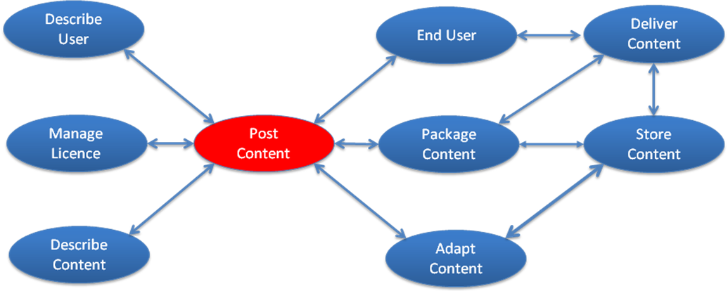
Figure 2 – A possible chain of Services centred around Post Content SP

In Figure 2 End User would contact Post Content SP who would get appropriate information from Describe Content SP and Describe User SP to prepare the sequence of song using its internal logic. He would then get the necessary licences from Manage Licence SP. The sequence of songs would then be handed over to Package Content SP possibly in the form of a Digital Item. Package Content SP will get the Resources from Store Content SP and hand over the Packaged Content to Deliver Content SP who will stream the Packaged Content to End User. Note that the sequence of songs could be generated on the fly based on the changing moods of the group of Users specified by End User and streamed as a Digital Item.

It is clear that in many real-world AIT value chains Service Providers would not be able to exploit the potential of the standard if they were confined to only offer “Elementary Services”. Therefore they will typically offer bundles of Elementary Services called Aggregated Services”. In the example of Figure 2 Post Content SP may wish to bundle e.g. the roles of Describe User and Package Content.

Furthermore, in general there will be a plurality of Service Providers offering the same or partially overlapping Aggregated Services, e.g. a Service Provider offering Content Identification Services, may offer Content Description Services as well (see Figure 3).

It is also important to note, by examining Figure 2, that the term “AIT value chain” does not really convey the complex nature, hardly similar to a traditional linear value chain, of the network of relationships that can be established by actors of an AIT ecosystem. Still, in the following the expression “AIT value chain” will be preferred to the more precise “AIT value network”.

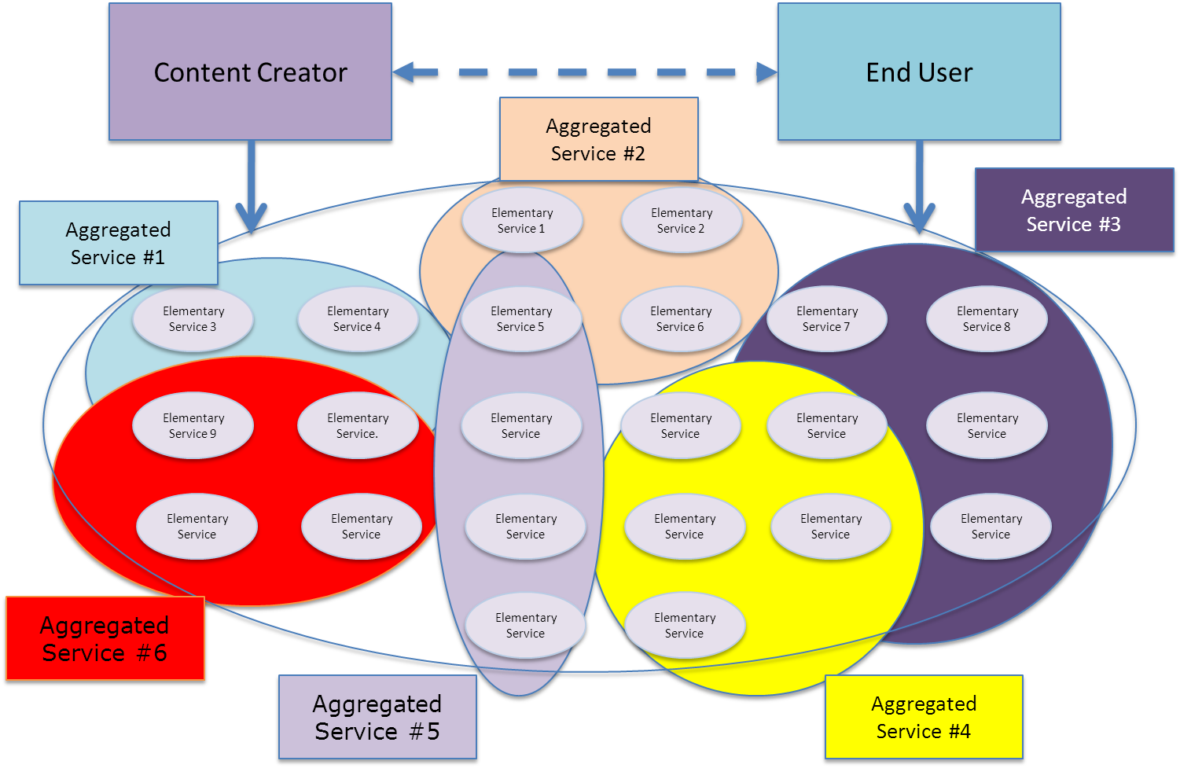

Figure 3 – An AIT value chain with Aggregated Service SPs

Thanks to the AIT standard, any Service Provider and any End User will be technically able to join an AIT value chain. Of course, a Service Provider will have to comply with the governance rules in order to do business in a specific AIT value chain. Ditto for an End User who wants to access the services offered by an AIT value chain.

Features
The AIT standard will comprise a set of protocols, including the format of the exchanged information, and APIs to access the services offered by the eco-system players depicted in Figures 1 and 2, so that a thriving digital media economy can be established that will enable the creation and provisioning of vastly enhanced IPTV services where
- Developers can offer AIT service components to the professional market enabled by the standard AIT component services API;
- Manufacturers can offer AIT devices to the global consumer market because of the global reach of AIT services;
- Service providers can set up and launch new attractive AIT services because of the ease to design and implement innovative AIT value chains;
- Users can seamlessly create, offer, search, access, pay/cash and consume AIT services.

Of particular importance is the possibility given to Users by the AIT standard to provide/access horizontal (i.e. interoperable) services, e.g.
- Network resources
- Content packaging (e.g. DRM)
- Content posting (e.g. EPG)
- Transactions

The AIT standard will support and extend many of the features that are now being taken for granted in current services such as opening of service APIs, third party application development, social networking, innovative content delivery mechanisms, and user tagging. The flexible service framework of the AIT standard will enable the use of some of the recent or emerging MPEG and ITU-T standards such as rich media-based interaction with the user, virtual spaces etc., in addition to other future technologies.

The AIT standard will extend the terminal capabilities with advanced features such as:
- Content generation, processing, and distribution by a large number of users
- Easy creation of new services
- Global, seamless and transparent use of content (regardless of geo-location, service provider, network provider, and device manufacturer)
- Diversity of user experience through easy installation of applications produced by a global community of developers

A number of use cases that illustrate the benefits for the IPTV ecosystem and requirements derived from the use cases have already been collected and can be found at [1] (AIT Use Cases) and [2] (AIT Requirements).

Benefits
- Anybody can implement AIT standard-based value chains and terminals
- Anybody can provide contents or services compliant to AIT standard
- Anybody can access a service or content compliant to AIT standard
- Anybody can provide services to terminals compliant to AIT standard, independently of
  - Connectivity
  - Network
  - Content Management and Protection
  - Transaction system
  - User interface
- Collaborative content creation, distribution and consumption by large number of participants
- Simplified service adaptation between various hardware platforms.

An Example Architecture for AIT Services
The AIT standard can be implemented as an extension of the MPEG eXtensible Middleware (MXM) standard under development as it can be seen from Figure 4 showing a general MXM value chain. It can be seen that in such MXM value chain some of the AIT Elementary Services of (e.g. Content Identification, Licence Provisioning etc.) are already present.

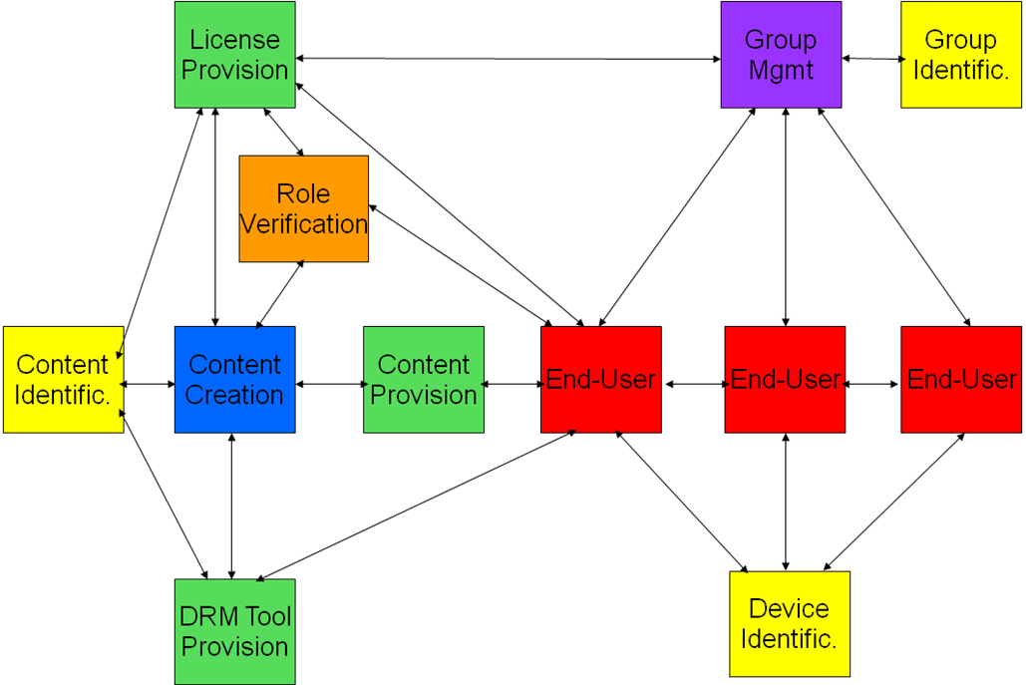
Figure 4 – An example of AIT value chain with different players

The MXM technology allows communication between two MXM Devices is accomplished via Protocols, as indicated in Figure 5.

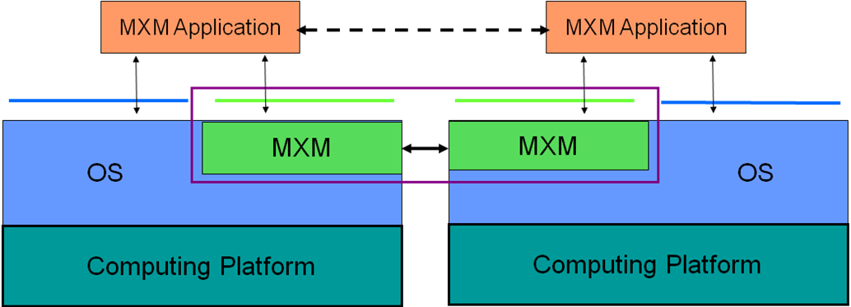
Figure 5 – Communication between two MXM Devices
Figure 6 below shows the detail of the MXM architecture.
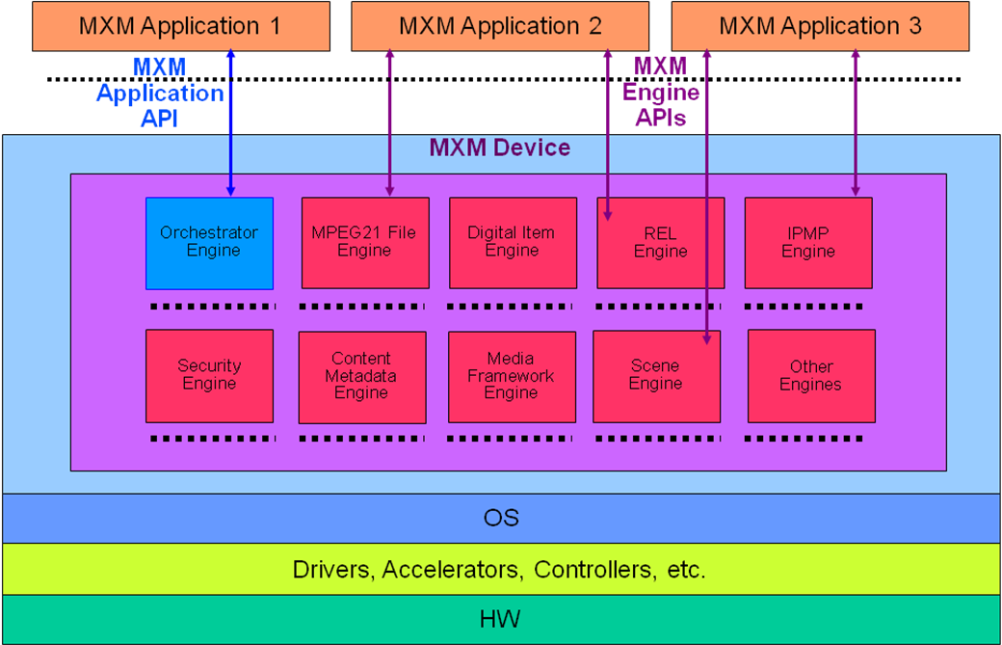
Figure 5 – The MXM architecture
The components of the MXM architecture are
- MXM Engines, collections of specific technologies that it is appropriate to bundle together
- MXM Engine APIs, that can be used to access MXM Engine functionality
- Orchestrator Engine, a special MXM Engine capable of creating chains of MXM Engines to execute a high-level application call (e.g. “Play”)
- MXM Application API, the API of the MXM Orchestrator Engine
- MXM Device, a device equipped with MXM
- MXM Application, an application that runs on an MXM Device and makes calls to the MXM Application API and MXM Engine APIs

Therefore it can be expected that many AIT functions can be implemented as extensions of the MXM architecture, specifically
- New Engines for new services
- New Protocols
- New APIs
- New Orchestrator Engine functionalities for aggregating services
- New Applications representing new aggregated services

Timeline
The timeline below is provided as a reference. While MPEG and Q.13/16 will make all efforts to keep the schedule, it should not be taken as an engagement on the part of MPEG as well as Q.13/16 to stick to it.

Time | Place | Expected Event
2010/01/22 | Kyoto | Call for Proposals issued
2010/04/12 |  | Deadline for proposal submission
2010/04/18 | Dresden | Evaluation of proposals (in an Ad Hoc Group meeting)
2010/04/23 | Dresden | Approval of first Working Draft
2010/07/30 | Geneva | Approval of Committee Draft
2010/10/22 | Guangzhou | Study on Committee Draft
2011/01/28 | (KR) | Approval of Final Committee Draft
2011/04/25 | Geneva | Study on Final Committee Draft
2011/07/21 | Torino | Approval of Final Draft International Standard

References
[1] | ITU-T Recommendation H.721, “The IPTV Terminal (Basic Model)”
[2] | Draft ITU-T Recommendation for Full-Fledged IPTV Terminal
[3] | Draft ITU-T Recommendation for Mobile IPTV Terminal
[4] | ISO/IEC 23004, Information Technology – MPEG Multimedia Middleware (MPEG-E)
[5] | ISO/IEC 23006, Information Technology – MPEG Extensible Middleware (MPEG-M)
[6] | Requirements for Advanced IPTV Terminal (AIT). N11228, Kyoto, Japan. January 2010.
[7] | Use Cases for Advanced IPTV Terminal (AIT). N11231, Kyoto, Japan. January 2010.
[8] | Advanced IPTV Terminal (AIT): Call for Proposals. N11229, Kyoto, Japan. January 2010.

